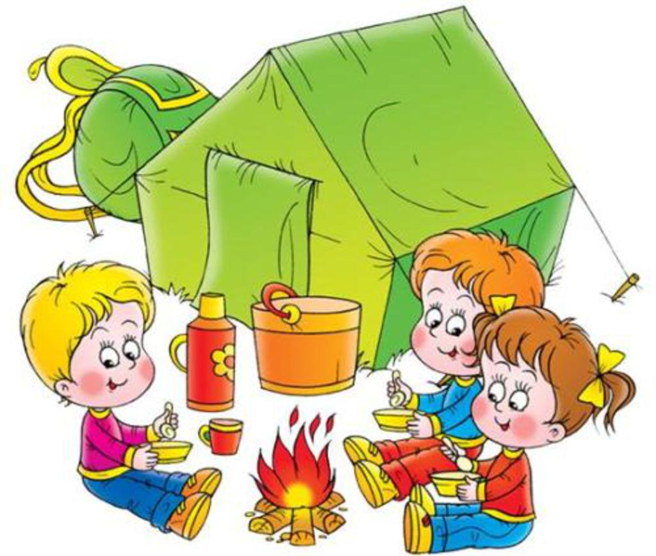

Look at this picture! In this picture I can see three children: two boys and a girl. It is summer. The weather is fine. It is warm.
The children are sitting around the bonfire. In the background there is a green tent. Behind the tent I can see a rucksack. It’s green and yellow.
The children are hungry and tired, but very happy. They have plates and spoons in their hands. They are eating.
The boy with fair hair is wearing a purple sweatshirt, blue trousers and brown boots.
The boy with brown hair is wearing a blue sweatshirt, red trousers and yellow boots.
The girl is wearing a red sweatshirt, blue trousers and yellow boots.
I like this picture, because I like summer. I like to go camping.

Look at this picture! In this picture I can see three children: two boys and a girl. It is winter. The weather is fine. It is cold.
The children are sitting around the bonfire. In the background there is a red tent. Behind the tent I can see a rucksack. It’s green and yellow.
The children are hungry and tired, but very happy. They have cups and spoons in their hands. They are eating.
The boy with fair hair is wearing a purple T-shirt, green trousers and brown boots.
The boy with brown hair is wearing a yellow sweatshirt, red shorts and yellow boots.
The girl is wearing a red shirt, blue trousers and yellow slippers.
I like this picture, because I like summer. I like to go camping.

Look at this picture! In this picture I can see three children: two boys and a girl. It is winter (summer). The weather is fine. It is cold (warm).
The children are sitting around the bonfire. In the background there is a red (green) tent. Behind the tent I can see a rucksack. It’s green and yellow.
The children are hungry and tired, but very happy. They have cups (plates) and spoons in their hands. They are eating.
The boy with fair hair is wearing a purple T-shirt (sweatshirt), green (blue) trousers and brown boots.
The boy with brown hair is wearing a yellow (blue) sweatshirt, red shorts (trousers) and yellow boots.
The girl is wearing a red shirt (sweatshirt), blue trousers and yellow slippers (boots).
I like this picture, because I like summer. I like to go camping.

